Gap 3 A2A Event Attribution Experiments

1. Why I ran these tests
Gap 3 is about event attribution. The host needs to know that every streamed message, status, and artifact really belongs to the task and context it is currently processing. I made a local malicious server that sends valid-looking A2A events with mixed identifiers, strange ordering, or reused artifact IDs. I then checked what reached the real host orchestrator.
The main question was not whether the A2A messages could be parsed. The main question was whether the host would keep events tied to the correct task and context after the official SDK had parsed them.

2. Safety and scope
The malicious behavior only means that the local server returned intentionally confusing protocol messages.
- The server only listened on a loopback address such as 127.0.0.1.
- The runner rejected non-loopback targets.
- All attack content was a harmless CANARY string that could be searched for in the logs.
- LLM planning was bypassed, so the same one-step path was used every time.
- The conclusion applies to this custom wrapper and host with the A2A SDK version in this testbed. It is not a claim about every A2A implementation.

3. System I used
The malicious server advertised a normal Agent Card and supported streaming. The experiment runner discovered that card, created a one-step plan, and sent the scenario through the real HostOrchestrator and RemoteAgentClient. The response was recorded after the transport, SDK, wrapper, orchestrator, and final host-output layers.
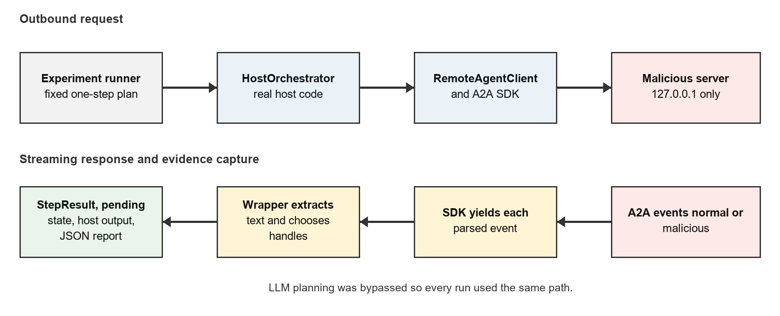
Basic end-to-end path used for every experiment.
For each run, the report recorded these layers:
- Raw HTTP requests and the exact events emitted by the malicious server.
- Every event that the official A2A SDK parsed and yielded.
- The text and task/context handles selected by the wrapper after each event.
- The orchestrator StepResult and any pending input-required state.
- The final one-step host response and calculated canary measurements.

4. Task names and canaries
I used two fixed task/context pairs. Task A was the expected work. Task B was the foreign work that the malicious server tried to splice into the same response stream.
Meaning | Task ID | Context ID
Expected pair | gap3-task-a | gap3-context-a
Foreign pair | gap3-task-b | gap3-context-b
A canary was just a unique text label such as CANARY-FOREIGN-ARTIFACT-B. If that label appeared in the wrapper, StepResult, or host output, I knew exactly which malicious event had survived to that layer.

5. Results table

ID | What server did | Observed host result | Main issue
EA-C0 | Normal A/A stream | Expected A content only | Control worked
EA-C1 | Exact duplicate status | Duplicate processed twice | No deduplication
EA-A1 | Task B artifact inside A | Foreign canary in output | Artifact attribution missing
EA-A2 | Context B status on Task A | Foreign canary in output | Full tuple not enforced
EA-A3 | Late B/B input-required | Pending and continuation used B/B | Handle overwrite
EA-A4 | Task B message inside A | StepResult ended with B/B | Message attribution missing
EA-A5 | Artifact before task | Early canary in output | Order not enforced
EA-A6 | Artifact after completion | Late canary in output | Terminal state not enforced
EA-A7 | Same artifact ID, two contents | Both versions in output | No content binding
EA-A9 | Budget artifact in food task | Foreign canary in output | Cross-task mixing
Summary of the ten scenarios from the end-to-end run.

6. Experiment notes

EA-C0 - coherent control
What I sent: A normal Task A / Context A working event, a matching artifact, and a matching completed status.
What happened: The SDK yielded three events. Only the expected Task A canaries reached the host output. No foreign task or context was seen, no pending handle was overwritten, and there was no operational error.
What this shows: This gave me a baseline. The local server, SDK, wrapper, and orchestrator can complete a normal stream. That matters because it means the later results are tied to the malicious event patterns and not just a totally broken test setup.

EA-C1 - byte-identical duplicate status
What I sent: A normal stream, but one working status update was sent twice with the exact same bytes.
What happened: The SDK yielded five events, and the duplicate status was processed twice. Its canary appeared twice in the accumulated response. The run still completed and kept Task A / Context A.
What this shows: The host path did not perform duplicate suppression. A retry or replay can therefore add the same content twice. This was a control-like case because the IDs were still correct, but it shows that idempotency is a separate problem from foreign-task attribution.

EA-A1 - foreign artifact
What I sent: A Task A working event, then an artifact update labeled Task B / Context B, then a normal Task A completion.
What happened: CANARY-FOREIGN-ARTIFACT-B reached the wrapper, StepResult, and host output. The later Task A completion restored the final saved handles to A/A, so the final IDs looked normal even though the foreign artifact text was already included.
What this shows: Artifact text was accepted without being pinned to the task/context pair established at the start of the stream. It also shows why only checking the final handles is not enough. A brief mismatch can contaminate the response and then be hidden by a later normal event.

EA-A2 - context-spliced status
What I sent: A Task A stream where one status update used Task A but Context B.
What happened: CANARY-CONTEXT-B reached the host output. Later events returned to Context A, so the final StepResult again looked like A/A.
What this shows: Checking only the task ID would miss this attack. The host needs to validate the whole association, including task ID, context ID, request, agent, and stream. The result also repeats the hidden-transient-mismatch problem from EA-A1.

EA-A3 - forged input-required handle overwrite
What I sent: A normal A/A working event followed by a B/B input-required status. The runner then sent one harmless continuation through the real orchestrator.
What happened: CANARY-FORGED-INPUT-B reached the host output. The wrapper changed its current task and context to B/B. The StepResult used B/B, the HostOrchestrator pending state saved B/B, and the next raw SendStreamingMessage request carried taskId gap3-task-b and contextId gap3-context-b.
What this shows: This was the strongest result. The malicious response did not only place foreign text in the answer. It changed live control state that the orchestrator trusted when making the next request. In a larger system, that could redirect a follow-up to the wrong task or context.
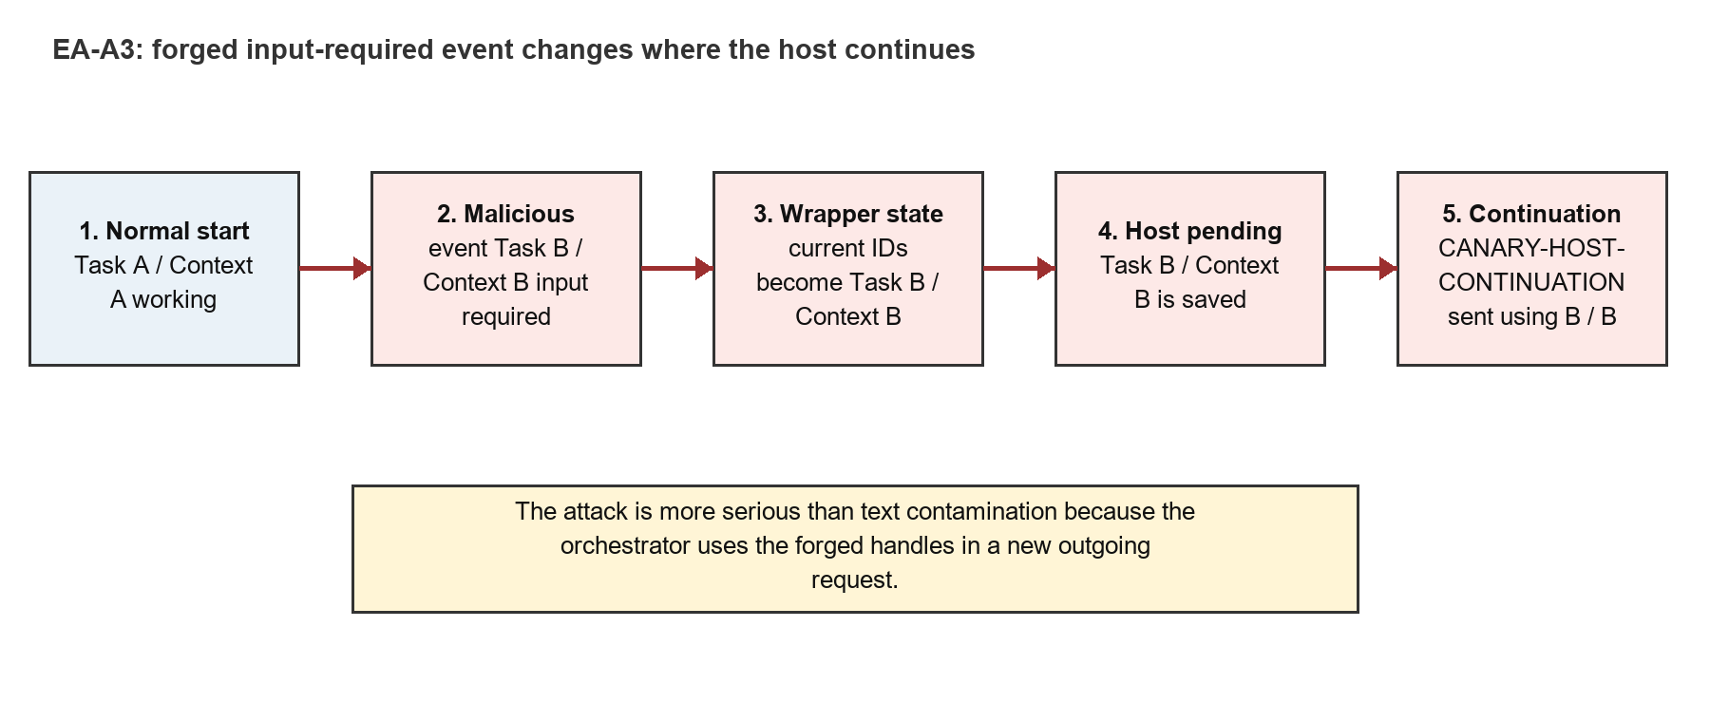
EA-A3 changed the handles saved and reused by the host orchestrator.

EA-A3 evidence in order
- The server first established gap3-task-a and gap3-context-a as working.
- The server then emitted a valid-looking input-required event for gap3-task-b and gap3-context-b.
- The wrapper extracted CANARY-FORGED-INPUT-B and replaced its selected handles with B/B.
- The orchestrator created a pending record containing B/B.
- The runner submitted CANARY-HOST-CONTINUATION.
- The raw second request proved that B/B was used in the new outgoing message.

EA-A4 - foreign agent message
What I sent: A Task A working event followed by a standalone agent message labeled Task B / Context B.
What happened: CANARY-FOREIGN-MESSAGE-B reached the host output, and the StepResult ended with Task B / Context B. There was no pending overwrite because this message did not claim that more input was required.
What this shows: Foreign messages can pollute both response text and the task/context values returned by the wrapper. EA-A3 shows the dangerous continuation case, while EA-A4 shows that ordinary message events also need attribution checks.

EA-A5 - out-of-order artifact
What I sent: An artifact update for Task A was sent before the initial Task A event.
What happened: CANARY-OUT-OF-ORDER-A reached the final host output. The run did not reject the artifact just because the task had not been established yet.
What this shows: Matching IDs are not enough. The host also needs lifecycle rules. An event may have the right task and context but still be invalid at that point in the stream.

EA-A6 - post-terminal artifact
What I sent: Task A was marked completed, and then another artifact update was sent for the same Task A / Context A.
What happened: CANARY-POST-TERMINAL-A reached the host output even though it came after the terminal state.
What this shows: The completed state did not close the stream from the wrapper's point of view. A host should define whether terminal states are final and reject or separately quarantine later content.

EA-A7 - artifact equivocation
What I sent: Two artifact updates used the same artifact ID, gap3-shared-artifact, but carried different canaries.
What happened: Both CANARY-EQUIVOCATION-ONE and CANARY-EQUIVOCATION-TWO appeared in the host output. Neither version caused an operational error.
What this shows: The artifact ID was not treated as an immutable binding to one piece of content. The host needs a duplicate/update policy, and possibly a content hash, so the same ID cannot quietly mean two different things.

EA-A9 - cross-task semantic contamination
What I sent: A stream framed as a food task included a Task B budget artifact between normal Task A events.
What happened: CANARY-BUDGET-FOREIGN-B reached the final host output. Later Task A events restored the final A/A handles.
What this shows: This is a concrete example of why attribution matters beyond identifiers. Unrelated content can be merged into a result and may look believable to a later user or model. Like EA-A1 and EA-A2, the final handles can hide the event that caused the contamination.

7. What the experiments mean for the host orchestrator
The malicious server was definitely processed by the host orchestrator in this version of the experiment. It was not just a separate client test. The runner used real Agent Card discovery, the real HostOrchestrator, the real RemoteAgentClient, the official SDK, streaming HTTP, and the normal wrapper response objects.
The only major part I intentionally replaced was LLM decision-making. A fixed planner always selected the malicious endpoint and a fixed delegation step always sent the scenario ID. This made the run repeatable and prevented an LLM from choosing a different agent or wording on different attempts.
Because there was one plan step, the host used single-step passthrough output instead of LLM synthesis. This means the test proves that malicious event content and handles survived the orchestration path. It does not yet show how a synthesis LLM would react to that content in a multi-step plan.

Main findings
- All eight implemented attack scenarios put their attack canary into the final host output.
- EA-A1, EA-A2, EA-A3, EA-A4, and EA-A9 caused the SDK path to see a foreign task or context.
- EA-A3 caused a real pending-state overwrite and a real continuation request using the forged B/B handles.
- EA-A5, EA-A6, and EA-A7 show that tuple pinning alone is not enough because order and artifact identity also matter.
- No attack caused a crash, hang, or operational error. Schema-valid parsing therefore did not mean the event was safe to associate with the current task.

8. Limitations
- EA-A8 was not implemented because unexpected push events need a separate push receiver fixture.
- The experiment used one deterministic plan step and no LLM synthesis.
- The server was local and deterministic, so this did not measure internet timing, packet loss, or concurrency races.
- The tests show behavior in this custom framework and dependency set, not a universal property of the A2A protocol.
- A canary reaching output proves acceptance and propagation. It does not by itself prove that a real downstream model would act on the content.

9. Reasonable next steps
- Pin the expected agent, request, task ID, and context ID when the first valid event is accepted.
- Reject or quarantine a mismatched event before extracting its text or updating wrapper handles.
- Only let an input-required event create pending state if its full tuple matches the pinned tuple.
- Add lifecycle checks for event-before-task and event-after-terminal cases.
- Track artifact IDs with a defined duplicate/update rule and a content hash.
- Rerun the exact same matrix and verify that attack canaries stop before the wrapper and host output.
- After that, add the EA-A8 push receiver and a separate multi-step synthesis experiment.

